**LIFI DATA TRANSFER SYSTEM**

G. AMARNATH

P. MOURYA DEEPAK

V.REEMA RANI



Department of Electronics and Communication Engineering

MAHATMA GANDHI INSTITUTE OF TECHNOLOGY

(Affiliated to Jawaharlal Nehru Technological University, Hyderabad, T.S)

Chaitanya Bharathi P.O., Gandipet, Hyderabad – 500075

2022 - 2023

**LIFI DATA TRANSFER SYSTEM**

MINOR PROJECT REPORT

SUBMITTED IN PARTIAL FULFILLMENT

OF THE REQUIREMENTS FOR THE DEGREE OF

BACHELOR OF TECHNOLOGY

IN

ELECTRONICS AND COMMUNICATION ENGINEERING

BY

G. AMARNATH

P. MOURYA DEEPAK

V.REEMA RANI



Department of Electronics and Communication Engineering

MAHATMA GANDHI INSTITUTE OF TECHNOLOGY

(Affiliated to Jawaharlal Nehru Technological University, Hyderabad, T.S.)

Chaitanya Bharathi P.O., Gandipet, Hyderabad – 500075

2022 - 2023

**MAHATMA GANDHI INSTITUTE OF TECHNOLOGY**

(Affiliated to Jawaharlal Nehru Technological University, Hyderabad, T.S.)

Chaitanya Bharathi P.O., Gandipet, Hyderabad – 500075



# Department of Electronics and Communication Engineering

**CERTIFICATE**

Date: 11 January 2023

This is to certify that the Mini Project work entitled “**LIFI DATA TRANSFER SYSTEM”** is being carried out by:

**G. AMARNATH -19261A0470**

**P. MOURYA DEEPAK-19261A04A3**

**V.REEMA RANI -19261A04B9**

in partial fulfillment for the award of Degree of **BACHELOR OF TECHNOLOGY** in **ELECTRONICS** **AND** **COMMUNICATION** **ENGINEERING** by the Jawaharlal Nehru Technological University, Hyderabad during the academic year 2022-23.

The results embodied in this report have not been submitted by the student to any other University or Institution for the award of any degree or diploma.

**Mr. A. Bala Raju (Assistant Professor) Dr. S. P Singh**

**Project Guide Professor & Head of ECE**

**ACKNOWLEDGEMENT**

We express our deep sense of gratitude to our Guide Mr. A. Balraju, Assistant Professor for his valuable guidance and encouragement in carrying out our Project. We wish to express our sincere thanks to Dr. S.P. Singh, Professor and Head of the Department of Electronics and Communication Engineering, M.G.I.T., for permitting us to pursue our project and encouraging us throughout the Project.

We are highly indebted to our Faculty Liaison Dr. CH Raja, Associate Professor and Mr. S Srinivasa Rao, Sr. Associate Professor, Electronics and Communication Engineering Department, who has given us all the necessary technical guidance in carrying out this Project.

Finally, we thank all the people who have directly or indirectly help us through the course of our project.

G. AMARNATH

P. MOURYA DEEPAK

V. REEMA RANI

**ABSTRACT**

Li-Fi technology utilizes LED’s for transmitting data. It is subsidiary of optical remote communication technology utilizing light from LED to convey rapid communication. Apparent light communication works by turning the LED now and again at exceptionally high velocity, it can’t be seen by the human eye.

So here we develop a data transfer system that uses the Li Fi technology. This system serves the following advantages:

* High Speed Data Transfer
* No Wires Needed
* Reliable Communication with No Data Loss
* Low Cost of Developing the System

The system makes use of a LDR sensor module along with Arduino Uno, LCD display, basic electronics components, power supply and PCB board to develop this system. The system allows us to use Li-Fi medium for data transfer.

We make use of a Li-Fi transmitter to demonstrate this concept. We use Arduino nano with LED’s and resistor for transmitting the data using light. The Arduino Nano converts written text message into light flash data for transmission. The user needs to open the serial monitor in Arduino IDE and type the message to be transmitted.

On sending the message the Arduino Nano controls the LED’s flashlight to transmit the message. The Arduino encodes the message into a series of flashed and transmits this data using the LED light.

This light message as it falls on the LDR receiver, it is decoded and sent to the Arduino Uno for processing. The Arduino Uno decodes and processes the message sent and then displays it over an LCD display to complete the data transmission.

**TABLE OF CONTENTS**

**CERTIFICATE iii**

**ACKNOWLEDGEMENT iv**

**ABSTRACT v**

**TABLE OF CONTENTS vi**

**LIST OF FIGURES viii**

**LIST OF TABLES ix**

**CHAPTER 1-OVERVIEW 1-5**

1.1 Introduction 1

1.2 Main objectives of project 3

1.3 Literature Survey 3

1.4 Motivation 4

**CHAPTER 2-OVERVIEW OF THE COMPONENTS USED 6-23**

2.1 Arduino Uno 6

2.2 LCD JHD162A 9

2.3 Resistance 15

2.4 Photodiode 17

2.5 LDR Sensor Module 19

2.6 Light Emitting Diode (LED) 21

2.7 IC7805 Voltage Regulator 22

**CHAPTER 3-SYSTEM DESIGN AND WORKING 24-27**

3.1 Working of Transmitter Board 24

3.2 Working of Receiver Circuit 25

3.3 System Model 27

**CHAPTER 4-PROGRAM CODING 28-47**

4.1 Transmitter Coding 28

4.2 Receiver Coding 36

**CHAPTER 5-CODES FOR DATA TRANSMISSION 48-49**

5.1 Transmitter Character Codes 48

5.2 Receiver Character Codes 49

**CHAPTER 6-OBSERVATIONS 50**

**CHAPTER 7-DISCUSSIONS 51**

**CHAPTER 8-RESULTS 52**

**CHAPTER 9-CONCLUSIONS AND FUTURE SCOPE 53-62**

9.1 Conclusion 53

9.2 Future Scope 53

9.3 Applications 54

**REFERENCES 59**

**LIST OF FIGURES**

1.1 Li-fi Concept 2

1.2 Data Streaming 4

2.1 Layout of Arduino UNO 6

2.2 Pinout of Arduino UNO 7

2.3 LCD Block Diagram 11

2.4 Reverse Biased Diode Circuit 17

2.5 Photodiode Symbol 18

2.6 LDR Pin Diagram 19

2.7 Working of LDR 20

2.8 LED Pinout 22

2.9 Internal Block Diagram of IC7805 23

3.1 Practical Implementation of Transmitter 25

3.2 Receiver Circuit 26

3.3 Practical Implementation of Receiver 26

3.4 Overall System 27

8.1 Airways 54

8.2 Li-Fi in Hospitals 55

8.3 Traffic Communication 56

8.4 Street Light Communication 56

8.5 Li-Fi Hotspots 57

8.6 Smart Power Plants 58

8.7 Undersea Communication 58

**LIST OF TABLES**

2.1 Pin Configuration of Arduino UNO 9

2.2 Pin Configuration of LCD 11

2.3 LCD Pin Description 12

2.4 LDR Pin Instructions 14

2.5 LDR Pin Description 19

2.6 Sensor Specifications 21

2.7 Absolute Maximum Ratings 23

5.1 Transmitter Character Codes 48

5.2 Receiver Character Codes 49

6.1 Observation Table 50

**CHAPTER 1**

**OVERVIEW**

**1.1 INTRODUCTION:**

**Li-Fi** , or "**light fidelity**", refers to [wireless communication](http://en.wikipedia.org/wiki/Wireless_communication) systems using light from [light-emitting diodes](http://en.wikipedia.org/wiki/Light-emitting_diode) as a medium instead of traditional radio frequencies, as in technology using the trademark [Wi-Fi](http://en.wikipedia.org/wiki/Wi-Fi). Li-Fi is expected to be ten times cheaper than Wi-Fi. Li-Fi has the advantage of being able to be used in electromagnetic sensitive areas such as in aircraft and nuclear power plants without causing interference. The light waves cannot penetrate walls which makes a much shorter range, though more secure from hacking, relative to Wi-Fi. While the US Federal Communications Commission has warned of a potential spectrum crisis because Wi-Fi is close to full capacity, Li-Fi has almost no limitations on capacity. The visible light spectrum is 10,000 times larger than the entire radiofrequency spectrum. Researchers have reached data rates of 3.5 [Gbps](http://en.wikipedia.org/wiki/Gbps) and have set a goal of reaching 6 Gbps. The Li-Fi market is projected to be worth over $6 billion per year by 2018. Low reliability and high installation costs are the potential drawbacks.

The general term [visible light communication](http://en.wikipedia.org/wiki/Visible_light_communication) (VLC), includes any use of the visible light portion of the electromagnetic spectrum to transmit information. The term Li-Fi was coined by Harald Haas from the [University of Edinburgh](http://en.wikipedia.org/wiki/University_of_Edinburgh) in the UK. The D-Light project at Edinburgh's Institute for Digital Communications was funded from January 2010 to January 2012.Haas promoted this technology in his 2011 [TED Global](http://en.wikipedia.org/wiki/TED_Global) talk and helped start a company to market it. Pure VLC is an [original equipment manufacturer](http://en.wikipedia.org/wiki/Original_equipment_manufacturer) (OEM) firm set up to commercialize Li-Fi products for integration with existing [LED](http://en.wikipedia.org/wiki/LED)-lighting systems.

In October 2011, companies and industry groups formed the [Li-Fi Consortium](http://en.wikipedia.org/wiki/Li-Fi_Consortium), to promote high-speed optical wireless systems and to overcome the limited amount of radio-based wireless spectrum available by exploiting a completely different part of the electromagnetic spectrum. A number of companies offer unidirectional VLC products.

VLC technology was exhibited in 2012 using Li-Fi.By August 2013, data rates of over 1.6 [Gbps](http://en.wikipedia.org/wiki/Gbps) were demonstrated over a single-color LED. In September 2013, a press release said that Li-Fi, or VLC systems in general, do not require line-of-sight conditions. In October 2013, it was reported Chinese manufacturers were working on Li-Fi development kits.

VLC communication is modeled after communication protocols established by the [IEEE 802](http://en.wikipedia.org/wiki/IEEE_802) workgroup. This standard defines the [physical layer](http://en.wikipedia.org/wiki/Physical_layer) (PHY) and [media access control](http://en.wikipedia.org/wiki/Media_access_control)(MAC) layer. The standard is able to deliver enough data rates to transmit audio, video and multimedia services. It takes count of the optical transmission mobility, its compatibility with artificial lighting present in infrastructures, the defiance which may be caused by interference generated by the ambient lighting. The MAC layer allows to use the link with the other layers like the [TCP/IP](http://en.wikipedia.org/wiki/TCP/IP) protocol.

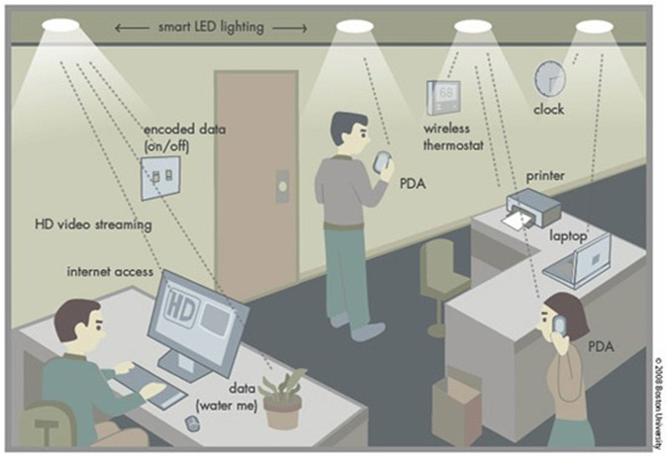

FIG 1.1 LI-FI CONCEPT

**1.2 MAIN OBJECTIVES OF PROJECT:**

To create a new class of high intensity light source of solid-state design bringing clean lighting solutions to general and specialty lighting. With energy efficiency, long useful lifetime, full spectrum and dimming, LI-FI lighting applications work better compared to conventional approaches. This technology brief describes the general construction of LI-FI lighting systems and the basic technology building blocks behind their function.

**1.3 LITERATURE SURVEY:**

As more and more people and their many devices access wireless internet, clogged airwaves are going to make it increasingly difficult to latch onto a reliable signal. But radio waves are just one part of the spectrum that can carry our data. What if we could use other waves to surf the internet? One German physicist, DR. Harald Haas, has come up with a solution he calls “Data Through Illumination”—taking the fiber out of fiber optics by sending data through an LED light bulb that varies in intensity faster than the human eye can follow. It’s the same idea behind infrared remote controls, but far more powerful. Haas says his invention, which he calls D-Light, can produce data rates faster than 10 megabits per second, which is speedier than your average broadband connection. He envisions a future where data for laptops, smart phones, and tablets is transmitted through the light in a room. And security would be a snap—if you can’t see the light, you can’t access the data.

Li-Fi is now part of the Visible Light Communications (VLC) PAN IEEE 802.15.7 standard. Li-Fi is typically implemented using white LED light bulbs. These devices are normally used for illumination by applying a constant current through the LED. However, by fast and subtle variations of the current, the optical output can be made to vary at extremely high speeds. Unseen by the human eye, this variation is used to carry high-speed data.

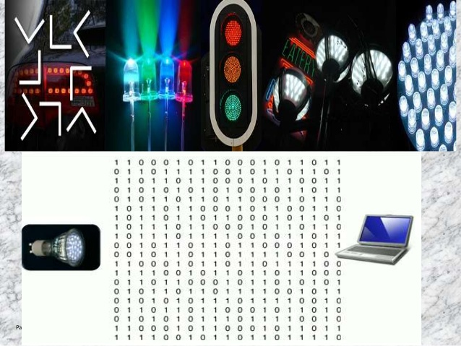

FIG 1.2 DATA STREAMING

**1.4 MOTIVATION:**

The capacity of radio waves is expensive less bandwidth insufficient spectrum  
availability of these radio waves is limited. These radio waves are not available in aircrafts or in hospitals. They are congested due to the high usage of 2G,3G,4G. The base stations used are only 5% efficient .95% of the efficiency is used in cooling the base stations. the security is also suffered. The wi-fi is penetrable through the wall. Security is the big issue here. One can hack the password. An unauthorized person can access the private matters. It is less economic. Availability of radio waves is less hence tariff rates are high. Due to this it is highly expensive. More over radio waves cannot pass under sea.

These drawbacks gave rise to find a new invention and a new method of communication that is visible light communication. This technology is yet to come in the market that is based on data communication through light. We tried to incorporate the communication through light in DTMF and microphone. We got this idea from the daily life gadget that is our own phone which gives us the inspiration to use a keypad similar to a phone which will help us in transferring numeric data through light. Not only this but also a microphone that is also an essential part of a phone, has been a part of our project too. Picking up these daily usable things and using it to transfer data has been our inspiration. We have tried to make it flexible, a potable, and a self-sustaining project. We make use of a Li-Fi transmitter android app to demonstrate this concept. The app converts written text message into light flash data for transmission. The user needs to start the app and type the message to be transmitted. It is subsidiary of optical remote communication technology utilizing light from LED to convey rapid communication. Apparent light communication works by turning the LED now and again at exceptionally high velocity, it can’t be seen by the human eye. This project cannot not only work on a white led light but any led light which can be connected to it. Hence making it a more environmentally friendly project which can be worked under any light.

**CHAPTER 2**

**OVERVIEW OF THE COMPONENTS USED**

# 2.1 Arduino UNO:

# Introduction:

Perhaps the most popular board in the Arduino line-up is the Arduino UNO. There are other boards like the Arduino Nano and the Arduino Mega, but UNO has been the go-to board for quick prototyping, Arduino Projects and DIY Projects.

Arduino UNO is based on ATmega328P Microcontroller, an 8-bit AVR Architecture based MCU from ATMEL. Arduino UNO comes in two variants: one consists of a 28-pin DIP Microcontroller while the other consists of 32 lead Quad Flat Package Microcontroller. Other than that, rest is identical in both the boards.

## Arduino UNO Board Layout:

The following image shows the layout of a typical Arduino UNO board. All the components are placed on the top side of the PCB.

[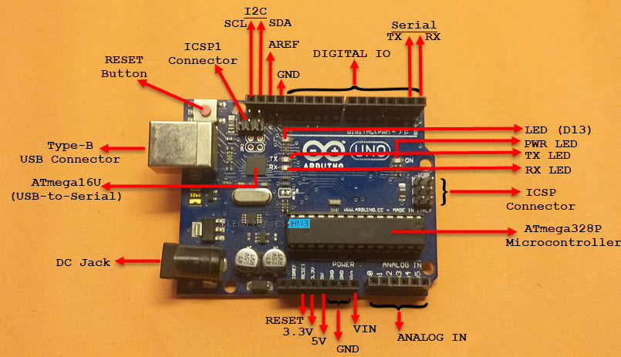](https://www.electronicshub.org/wp-content/uploads/2021/01/Arduino-UNO-Board-Layout.jpg)

Fig:2.1 Layout of Arduino UNO Board

As you can notice, there is a Type-B USB connector on the left short edge of the board, which is used for powering on the board as well as programming the Microcontroller. There is also a 2.1 mm DC jack to provide external power supply. Apart from that, the layout of Arduino UNO is very much self-explanatory.

## Arduino UNO Pinout:

Now that we have seen a little bit about Arduino UNO and its important features and specifications, let us dive into the Arduino UNO Pinout. The following image shows the complete pinout of Arduino UNO Board.

[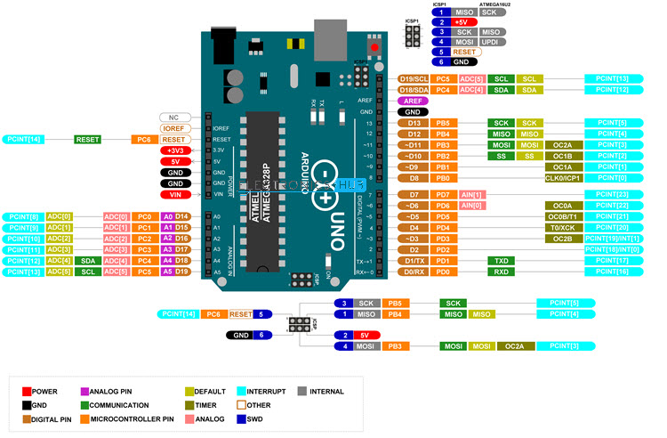](https://www.electronicshub.org/wp-content/uploads/2021/01/Arduino-UNO-Pinout.jpg)

Fig:2.2 Pinout of Arduino UNO

As you can see from the image, I described each pin of the Arduino UNO with its microcontroller equivalent pin, alternative functions, default functionality and other additional features.

**Pin Description:**

For pin description of Arduino UNO, let us assume some basic numbering. Let the numbering begin with the RX Pin (D0). So, RX is Pin 1, TX is Pin 2, D2 is Pin 3 and so on.

On the other side, NC is Pin 19, IOREF is Pin 20 etc. Overall, there are 32 pins on the Arduino UNO Board.

|  |  |  |  |
| --- | --- | --- | --- |
| **Pin Number** | **Pin Name** | **Description** | **Alternative Functions** |
| 1 | RX / D0 | Digital IO Pin 0  Serial RX Pin | Generally used as RX |
| 2 | TX / D1 | Digital IO Pin 1  Serial TX Pin | Generally used as TX |
| 3 | D2 | Digital IO Pin 2 |  |
| 4 | D3 | Digital IO Pin 3 | Timer (OC2B) |
| 5 | D4 | Digital IO Pin 4 | Timer (T0/XCK) |
| 6 | D5 | Digital IO Pin 5 | Timer (OC0B/T1) |
| 7 | D6 | Digital IO Pin 6 |  |
| 8 | D7 | Digital IO Pin 7 |  |
| 9 | D8 | Digital IO Pin 8 | Timer (CLK0/ICP1) |
| 10 | D9 | Digital IO Pin 9 | Timer (OC1A) |
| 11 | D10 | Digital IO Pin 10 | Timer (OC1B) |
| 12 | D11 | Digital IO Pin 11 | SPI (MOSI) Timer (OC2A) |
| 13 | D12 | Digital IO Pin 12 | SPI (MISO) |
| 14 | D13 | Digital IO Pin 13 | SPI (SCK) |
| 15 | GND | Ground |  |
| 16 | AREF | Analog Reference |  |
| 17 | SDA / D18 | Digital IO Pin 18 | I2C Data Pin |
| 18 | SCL / D19 | Digital IO Pin 19 | I2C Clock Pin |
| 19 | NC | Not Connected |  |
| 20 | IOREF | Voltage Reference |  |
| 21 | RESET | Reset (Active LOW) |  |
| 22 | 3V3 | Power |  |
| 23 | 5V | +5V Output from regulator or +5V regulated Input |  |
| 24 | GND | Ground |  |
| 25 | GND | Ground |  |
| 26 | VIN | Unregulated Supply |  |
| 27 | A0 | Analog Input 0 | Digital IO Pin 14 |
| 28 | A1 | Analog Input 1 | Digital IO Pin 15 |
| 29 | A2 | Analog Input 2 | Digital IO Pin 16 |
| 30 | A3 | Analog Input 3 | Digital IO Pin 17 |
| 31 | A4 | Analog Input 4 | Digital IO Pin 18 I2C (SDA) |
| 32 | A5 | Analog Input 5 | Digital IO Pin 19 I2C (SCL) |

Table 2.1 Pin configuration of Arduino

**2.2 LCD JHD162A:**

A liquid-crystal display is a flat panel, electronic visual display that uses the light modulating properties of liquid crystals. Liquid crystal does not emit light directly. The working of LCD depends on two sheets of polarizing material with a liquid crystal solution in between them. When an electric current is passed through the liquid, it causes the crystals to align so that it blocks out light and does not allow it to pass [ 10]. Each crystal behaves like a shutter, it either allows light to pass through or blocks the light.

It can function properly in the temperature range of -10℃ to 60℃ and has operating lifetime of longer than 50000 hours (at room temperature without direct irradiation of sunlight).

Features of LCD JHD162A:

* Display Mode: TN/STN
* Number of data line: 8-bit parallel
* Display type: Positive Translative
* Backlight: LED (B/5.0V)
* Viewing direction: 6 o’clock
* Operating Temperature: Indoor
* Driving Voltage: Single power
* Type: COB (Chip on Board)
* Connector: Pin
* Driving method: 1/16 duty,1/5 bias
* Display construction: 16 Characters * 2 Lines



Fig 2.3 LCD BLOCK DIAGRAM

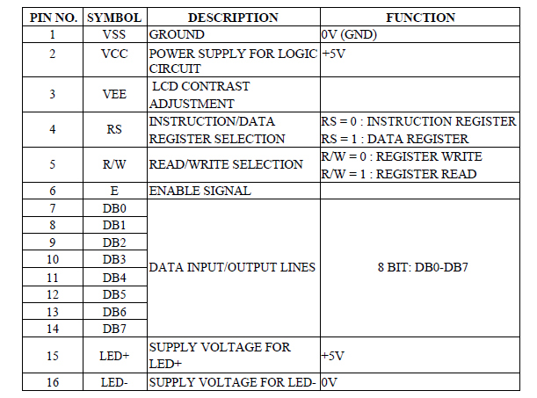

Table 2.2 PIN Configuration of LCD

## LCD Interfacing:

LCDs can add a lot to your application in terms of providing a useful interface for the user, debugging an application or just giving it a "professional" look. The most common type of LCD controller is the Hitachi 44780 which provides a relatively simple interface between a processor and an LCD. Using this interface is often not attempted by inexperienced designers and programmers because it is difficult to find good documentation on the interface, initializing the interface can be a problem and the displays themselves are expensive.

I have worked with Hitachi 44780 based LCDs for a while now and I have to say that I don't believe any of these perceptions. LCDs can be added quite easily to an application and use as few as three digital output pins for control. As for cost, LCDs can be often pulled out of old devices or found in surplus stores for less than a dollar.

The purpose of this page is to give a brief tutorial on how to interface with Hitachi 44780 based LCDs. I have tried to provide the all the data necessary for successfully adding LCDs to your application.

The most common connector used for the 44780 based LCDs is 14 pins in a row, with pin centers 0.100" apart. The pins are wired as:

|  |  |
| --- | --- |
| **Pins** | **Description** |
| 1 | Ground |
| 2 | VCC |
| 3 | Contrast Voltage |
| 4 | "R/S" _Instruction/Register Select |
| 5 | "R/W" _Read/Write LCD Registers |
| 6 | "E" Clock |
| 7 - 14 | Data I/O Pins |

Table 2.3 LCD Pin Description

As you would probably guess from this description, the interface is a parallel bus, allowing simple and fast reading/writing of data to and from the LCD.

This waveform will write an ASCII Byte out to the LCD's screen. The ASCII code to be displayed is eight bits long and is sent to the LCD either four or eight bits at a time. If four-bit mode is used, two "nibbles" of data (Sent high four bits and then low four bits with an "E" Clock pulse with each nibble) are sent to make up a full eight-bit transfer. The "E" Clock is used to initiate the data transfer within the LCD.

Sending parallel data as either four or eight bits are the two primary modes of operation. While there are secondary considerations and modes, deciding how to send the data to the LCD is most critical decision to be made for an LCD interface application.

Eight-bit mode is best used when speed is required in an application and at least ten I/O 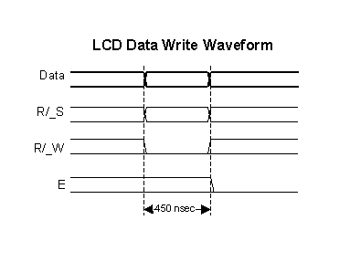pins are available. Four-bit mode requires a minimum of six bits. To wire a microcontroller to an LCD in four-bit mode, just the top four bits (DB4-7) are written to.

The "R/S" bit is used to select whether data or an instruction is being transferred between the microcontroller and the LCD. If the Bit is set, then the byte at the current LCD "Cursor" Position can be read or written. When the Bit is reset, either an instruction is being sent to the LCD or the execution status of the last instruction is read back (whether or not it has completed).

The different instructions available for use with the 44780 are shown in the table below it includes description

|  |  |  |  |  |  |  |  |  |  |  |
| --- | --- | --- | --- | --- | --- | --- | --- | --- | --- | --- |
| **R/S** | **R/W** | **D7** | **D6** | **D5** | **D4** | **D3** | **D2** | **D1** | **D0** | **Instruction/Description** |
| 4 | 5 | 14 | 13 | 12 | 11 | 10 | 9 | 8 | 7 | Pins |
| 0 | 0 | 0 | 0 | 0 | 0 | 0 | 0 | 0 | 1 | Clear Display |
| 0 | 0 | 0 | 0 | 0 | 0 | 0 | 0 | 1 | * | Return Cursor and LCD to Home Position |
| 0 | 0 | 0 | 0 | 0 | 0 | 0 | 1 | ID | S | Set Cursor Move Direction |
| 0 | 0 | 0 | 0 | 0 | 0 | 1 | D | C | B | Enable Display/Cursor |
| 0 | 0 | 0 | 0 | 0 | 1 | SC | RL | * | * | Move Cursor/Shift Display |
| 0 | 0 | 0 | 0 | 1 | DL | N | F | * | * | Set Interface Length |
| 0 | 0 | 0 | 1 | A | A | A | A | A | A | Move Cursor into CGRAM |
| 0 | 0 | 1 | A | A | A | A | A | A | A | Move Cursor to Display |
| 0 | 1 | BF | * | * | * | * | * | * | * | Poll the "Busy Flag" |
| 1 | 0 | D | D | D | D | D | D | D | D | Write a Character to the Display at the Current Cursor Position |
| 1 | 1 | D | D | D | D | D | D | D | D | Read the Character on the Display at the Current Cursor Position |

Table 2.4 LCD Pin Instructions

The bit descriptions for the different commands are:

"*" - Not Used/Ignored. This bit can be either "1" or "0"

Set Cursor Move Direction:

ID - Increment the Cursor After Each Byte Written to Display if Set

S - Shift Display when Byte Written to Display

Enable Display/Cursor

D - Turn Display On(1)/Off(0)

C - Turn Cursor On(1)/Off(0)

B - Cursor Blink On(1)/Off(0)

Move Cursor/Shift Display

SC - Display Shift On(1)/Off(0)

RL - Direction of Shift Right(1)/Left(0)

Set Interface Length

DL - Set Data Interface Length 8(1)/4(0)

N - Number of Display Lines 1(0)/2(1)

F - Character Font 5x10(1)/5x7(0)

Po

ll the "Busy Flag"

BF - This bit is set while the LCD is processing

Move Cursor to CGRAM/Display

A - Address

Read/Write ASCII to the Display

D - Data

Reading Data back is best used in applications which required data to be moved back and forth on the LCD (such as in applications which scroll data between lines). The "Busy Flag" can be polled to determine when the last instruction that has been sent has completed processing. In most applications, I just tie the "R/W" line to ground because I don't read anything back. This simplifies the application because when data is read back, the microcontroller I/O pins have to be alternated between input and output modes.

**2. 3 Resistance:**

Resistance is the opposition of a material to the current. It is measured in ohms. All conductors represent a certain amount of resistance, since no conductor is 100% efficient. To control the electron flow (current) in a predictable manner, we use resistors. Electronic circuits use calibrated lumped resistance to control the flow of current. Broadly speaking, resistor can be divided into two groups viz. Fixed & adjustable (variable) resistors. In fixed resistors, the value is fixed & cannot be varied. In variable resistors, the resistance value can be varied by an adjuster knob. It can be divided into (a) carbon composition (b) wire wound (c) special type. The most common type of resistors used in our projects is carbon type. The resistance value is normally indicated by color bands. Each resistance has four colors, one of the bands on either side will be gold or silver, this is called fourth band and indicates the tolerance, others three band will give the value of resistance (see table). For example, if a resistor has the following marking on it say red, violet, gold. Comparing these colored rings with the color code, its value is 27000 ohms or 27 kilo ohms and its tolerance is ±5%. Resistor comes in various sizes (power rating). The bigger, the size, the more power rating of 1/4 watts.

The four-color rings on its body tells us the value of resistor value as given below.

**colors code**

black 0

brown 1

red 2

orange 3

yellow 4

green 5

blue 6

violet 7

grey 8

white 9

The first rings give the first digit. The second ring gives the second digit. The third ring indicates the number of zeroes to be placed after the digits. The fourth ring gives tolerance (gold ±5%, silver ± 10%, no color ± 20%).

In variable resistors, we have the dial type of resistance boxes. There is a knob with a metal pointer. This presses over brass pieces placed along a circle with some space b/w each of them.

**2.4 PHOTODIODE:**

A photodiode is a type of [photo detector](http://en.wikipedia.org/wiki/Photodetector) capable of converting [light](http://en.wikipedia.org/wiki/Light) into either [current](http://en.wikipedia.org/wiki/Electric_current) or [voltage](http://en.wikipedia.org/wiki/Voltage), depending upon the mode of operation. The common, traditional [solar cell](http://en.wikipedia.org/wiki/Solar_cell) used to generate electric [solar power](http://en.wikipedia.org/wiki/Solar_power) is a large area photodiode.

Photodiodes are similar to regular [semiconductor](http://en.wikipedia.org/wiki/Semiconductor) [diodes](http://en.wikipedia.org/wiki/Diode) except that they may be either exposed (to detect [vacuum UV](http://en.wikipedia.org/wiki/Vacuum_UV) or [X-rays](http://en.wikipedia.org/wiki/X-rays)) or packaged with a window or [optical fiber](http://en.wikipedia.org/wiki/Optical_fiber) connection to allow light to reach the sensitive part of the device. Many diodes designed for use specifically as a photodiode use a [PIN junction](http://en.wikipedia.org/wiki/PIN_diode) rather than a [p-n junction](http://en.wikipedia.org/wiki/P-n_junction), to increase the speed of response. A photodiode is designed to operate in [reverse bias](http://en.wikipedia.org/wiki/Reverse_bias).

If a conventional silicon diode is connected in the reverse-biased circuit, negligible current will flow through the diode and zero voltage will develop across R1. If the diode casing is now carefully removed so that the diode's semiconductor junction is revealed, and the junction is them exposed to visible light in the same circuit, the diode current will rise, possibly to as

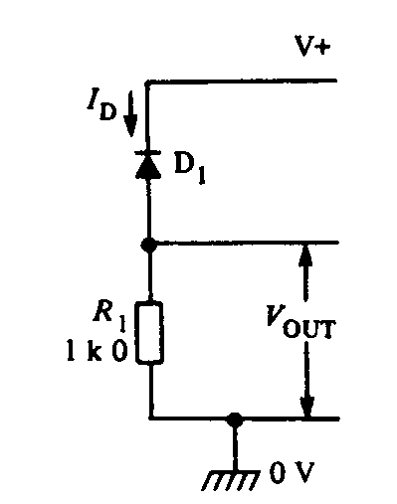

Fig 2.4 Reverse-biased diode circuit.

high as 1 mA, producing a significant output across R1. Further investigation will show that the diode current (and thus the output voltage) is directly proportional to light intensity, and that the diode is therefore photosensitive.

In practice, all silicon junctions are photosensitive, and a photodiode can be regarded as a conventional diode housed in a case that lets external light reach its photosensitive semiconductor junction. In use, the photodiode is reverse biased and the output voltage is taken from across a series-connected load resistor. This resistor may be connected between the diode and ground, or between the diode and the positive supply line.

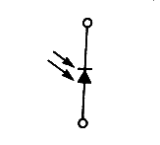

***Photodiode symbol***

Fig 2.5 Photodiode symbol

The human eye is sensitive to a range of light radiation. It has a peak spectral response to the color green, which has a wave length of about 550 nm, but has a relatively low sensitivity to the color violet (400 nm) at one end of the spectrum and to dark red (700 nm) at the other. Photodiodes also have spectral response characteristics, and these are determined by the chemistry used in the semiconductor junction material.

Photodiodes have a far lower light-sensitivity than cadmium-sulphide LDRs, but give a far quicker response to changes in light level. Generally, LDRs are ideal for use in slow-acting direct-coupled light-level sensing applications, while photodiodes are ideal for use in fast-acting AC-coupled signaling applications. Typical photodiode applications include IR remote-control circuits, IR beam switches and alarm circuits, and photographic flash slave circuits, etc.

**2.5 LDR SENSOR MODULE:**

LDR sensor module is a low-cost **digital sensor** as well as **analog sensor** module, which is capable to measure and detect light intensity. This sensor also is known as the **Photoresistor sensor**. This sensor has an onboard LDR (Light Dependent Resistor), that helps it to detect light. This sensor module comes with 4 terminals. Where the “DO” pin is a digital output pin and the “AO” pin is an analog output pin. The output of the module goes high in the absence of light and it becomes low in the presence of light. The sensitivity of the sensor can be adjusted using the onboard potentiometer

## ****2.5.1 LDR Sensor Module Pin Diagram:****

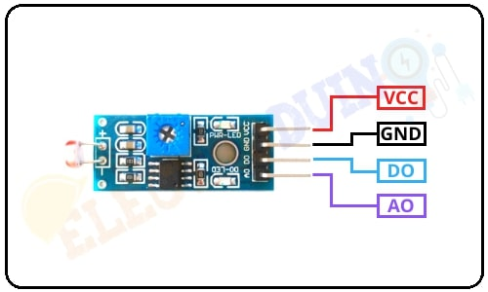

Fig 2.6 LDR Pin Diagram

|  |  |  |
| --- | --- | --- |
| **Pin No** | **Pin Name** | **Description** |
| 1 | **VCC** | +5 v power supply Input Pin |
| 2 | **GND** | Ground (-) power supply Input Pin |
| 3 | **DO** | Digital Output Pin |
| 4 | **AO** | Analog Output Pin |

Table:2.5 LDR Pin Description

## ****2.5.2 How IR Sensor Module Works:****

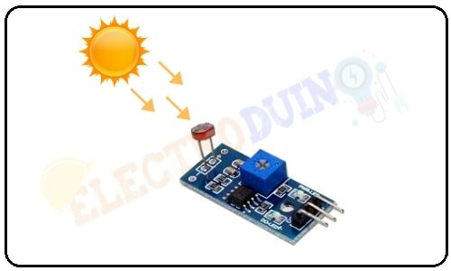

Fig:2.7 Working of LDR

First of all, we need to connect the LDR sensor module to a 5v power supply. Then set the **threshold voltage** at the **non-Inverting input (3)** of the IC according to the present light intensity by rotating the preset knob for setting the sensor sensitivity.

When **light intensity increases** on the surface of the LDR then the resistance of the LDR decreases. Then the **maximum** amount of **voltage** will be allocated across the **resistor(R3)**. So, a **Low amount** of voltage from the LDR is given to the **Inverting input (2)** of the IC. Then the Comparator IC compares this voltage with the threshold voltage. In this condition, this input voltage is **less than** the threshold voltage, so the sensor output goes **LOW (0)**.

In contrast, when **light intensity decrease (low/dark)** on the surface of the LDR then the resistance of the LDR increases. Then the **maximum** amount of **voltage** will be allocated across the **LDR (R2)**. So, a **high amount** of voltage from the LDR is given to the **Inverting input (2)** of the IC. Then the Comparator IC compares this voltage with the threshold voltage. In this condition, this input voltage is **greater than** the threshold voltage, so the sensor output goes **High (1)**.

|  |  |
| --- | --- |
| **Parameter** | **Value** |
| Operating voltage | 5V or 3.3V DC |
| Comparator chip | LM393 |
| Module Pins | 3 pins |
| Output type | Digital outputs (D0) |
| Sensitivity | Adjustable |
| Indicator LED | Output and power LED indicator |
| PCB size | 3cm * 1.6cm |
| Fixed Hole Diameter | 3mm |

## ****Table:2.6 Sensor Specifications****

**2.6 Light Emitting Diode (LED):**

The LED is a two-terminal semiconductor light source that emits light when current flows through it. The word LED meaning or LED full form is **Light Emitting Diode**. The Light Emitting Diode is a special type of **p-n junction diode** which is made of special type **doped semiconductor** materials. The LED or Light Emitting Diode allows the flow of current in the forward direction and blocks the current in the reverse direction. When the current flow in the forward direction then LED releases energy in the form of **photons**.

## ****2.6.1 Light Emitting Diode Pinout:****

LED Consists of **two terminals**. These are one is **positive or anode** and another one is **negative or cathode**. LED has three different methods to identify its terminals.

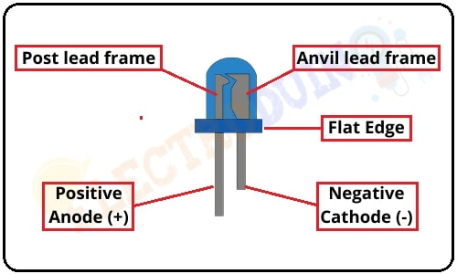

Fig 2.8 LED Pinout

1. The **Long terminal** of the LED is the **positive or anode (+)** terminal and the **short terminal** of the LED is the **negative or cathode (-)** terminal.
2. Try to find the **flat edge** on the LED outer casing. The terminal or pin **nearest the flat edge** is a **negative or cathode** terminal or pin. And the other one is a positive or anode terminal or pin.
3. If LED is transparent to look inside. So, we can easily identify by the lead frame. The anvil lead frame connected to the cathode terminal and the post lead frame is connected to the anode terminal.

**2.7 IC 7805 voltage regulator:**

The IC 7805 of three terminal positive regulators available with several fixed output voltages, making them useful in a wide range of applications. Each type employs internal current limiting, thermal shut down and safe operating area protection, making it essentially indestructible. If adequate heat sinking is provided, they can deliver over 1 A output current. Although designed primarily as fixed voltage regulators, these devices can be used with external components to obtain adjustable voltages and currents.

Features

• OutputCurrentupto1A

• OutputVoltagesof5,6,8,9, 10,12,15, 18,24V

• Thermal Overload Protection

• Short Circuit Protection

• Output Transistor Safe Operating Area Protection

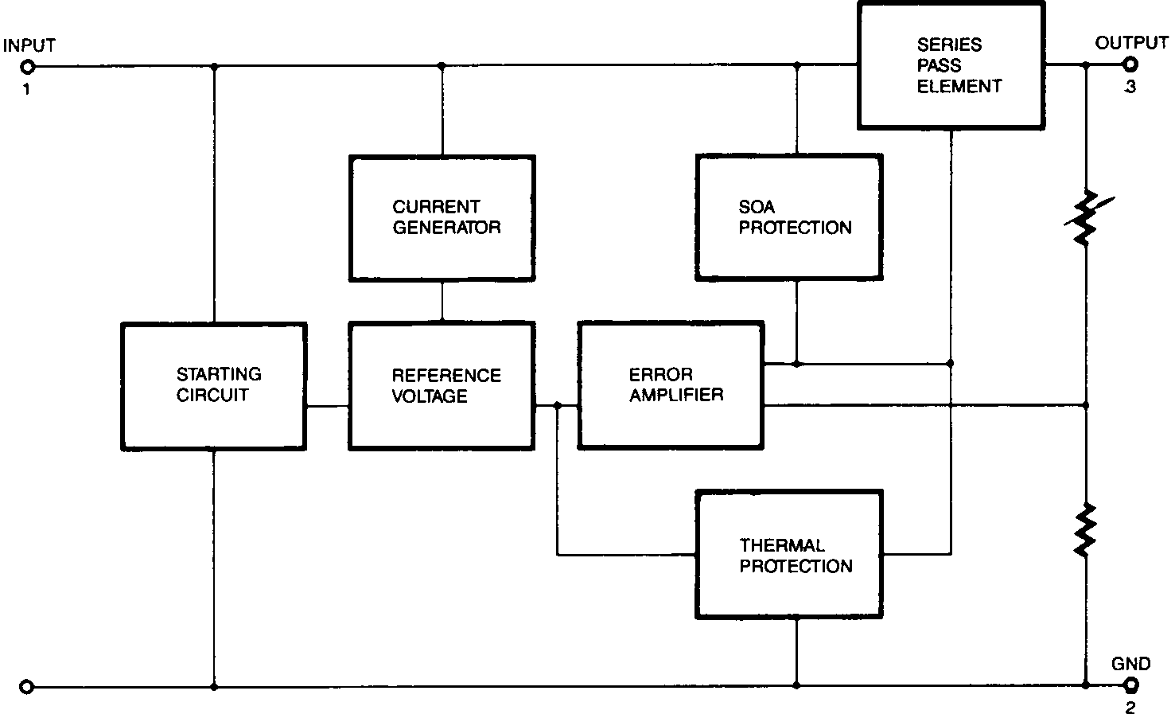

Fig 2.9 Internal Block Diagram

|  |  |  |  |
| --- | --- | --- | --- |
| Parameter | Symbol | Value | Unit |
| Input Voltage (for VO=5Vto18) (for VO=24V) | VI  VI | 35  40 | V |
| Thermal Resistance Junction-Cases (TO-220) | RJC | 5 | oC/W |
| Thermal Resistance Junction-Air (TO-220) | RJA | 65 | oC/W |
| Operating Temperature Range | TOPR | 0~+125 | Oc |
| Storage Temperature Range | TSTG | -65~+150 | Oc |

Table 2.7 Absolute Maximum Ratings

**CHAPTER 3**

**SYSTEM DESIGN AND WORKING**

**3.1 WORKING OF TRANSMITTER BOARD:**

The transmitter section comprises of a keyboard connected with a PS2 connector and interfaced directly with microcontroller IC AT89S52. IC AT89S52 also referred as 8051, is a 40 pin IC, used to provide serial data communication. A crystal oscillator with a frequency of 11.0592 MHz is used to provide the desired clock frequency to the microcontroller for its working. Two paper capacitors of 27 pf are used to stabilize the clock frequency.

A 9v dc voltage is provided to the transmitter section with the help of a battery, which is step down to 5v using voltage regulator IC 7805. A capacitor of 10uf and a resistor of 10k ohms are connected with the microcontroller to provide the reset function. Two transistors, one NPN (IC TIP L6 122) and the other PNP (IC BC5578) are together used as a Darlington pair and are used to provide push pull amplification. The output of this transistor pair is connected to a led torch. A green led is used which glows if the caps lock key is on.

The keyboard can be used to send alphanumeric data. The spacebar, backspace, delete and enter commands can also be used. If the caps lock key is on then alphabets in the uppercase and special characters (!, @, #, $, %, ^, &, *, (,)) can also be transmitted. When a key is pressed on the keyboard, the ASCII code of that key is sent directly to the microcontroller. The microcontroller converts the ASCII code into binary and sends this data to the transistor pair. The PNP transistor works at off state i.e., it reads zero in the binary code, while the NPN transistor works at on state i.e., it read one in the binary code. This transistor pair then sends the binary pulse containing zeros and ones to the led torch. The led torch is on when it reads a one and is off when it reads a zero. The blinking of led light is so fast that it cannot be detected by a human eye.

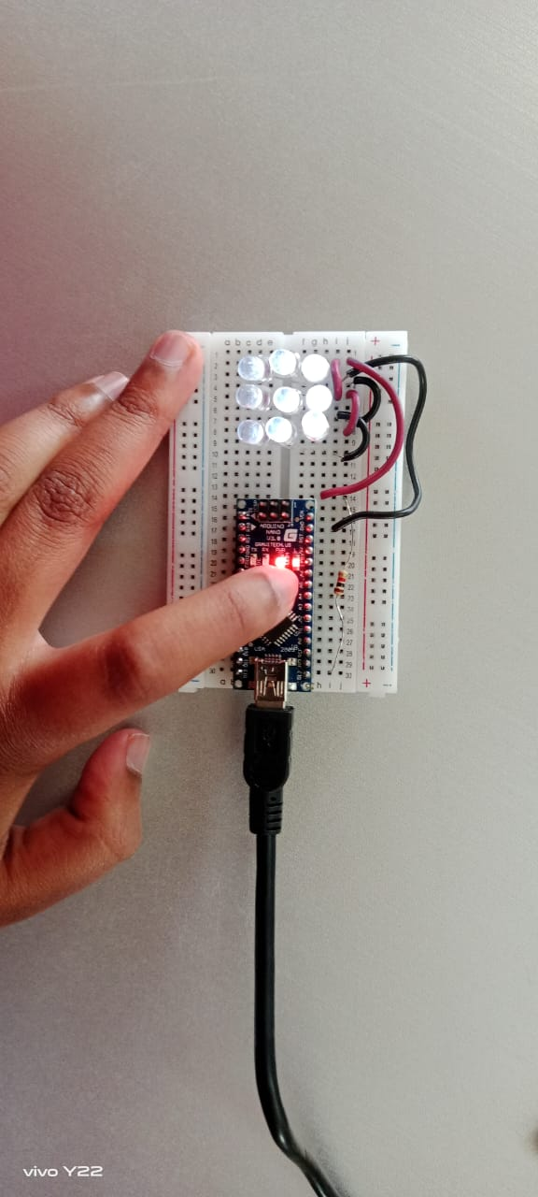

FIG 3.1 PRACTICAL IMPLEMENTATION OF TRANSMITTER

**3.2 WORKING OF RECEIVER CIRCUIT:**

The receiver section comprises of a photodiode connected to the PNP transistor (IC BC 5578). A 9v battery is attached to the circuit to provide the power supply. A voltage regulator IC 7805 is used to step down the 9v dc supply to 5v dc supply for the working of the microcontroller AT89S52. The microcontroller is connected with a crystal oscillator of 11.0592 MHz to provide the clock frequency, along with two paper capacitors of 27pf to stabilize this frequency. A 10 uf capacitor is also connected to the microcontroller to provide the reset function. A button switch is used to provide the manual reset function. The microcontroller is interfaced with the 16x2 LCD to display the data that is sent by the transmitter.

The light from the led torch is made to fall on the photodiode. The photodiode detects the blinking of the led, and transmits this train of ones and zeros to the transistor. The PNP transistor is in on state when a zero is detected by it and is in off state when a one is detected. This on and off state of transistor is read by the microcontroller and it converts this binary code so formed as a result of on and off, into an ASCII code. The microcontroller then sends this ASCII code to the 16x2 LCD for display, which is directly interfaced with microcontroller.

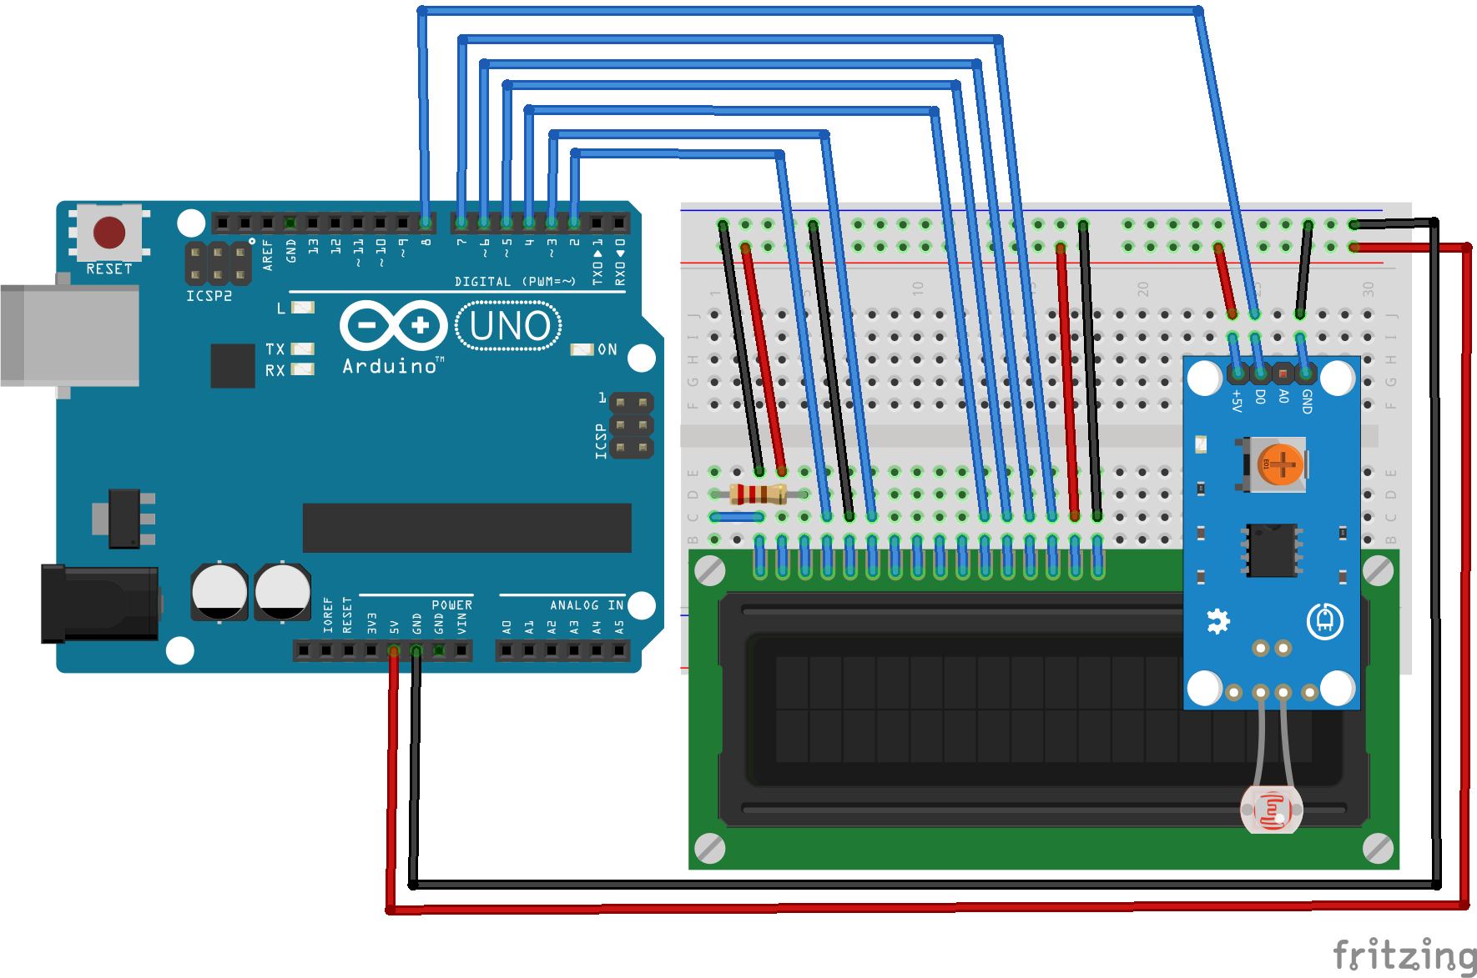

FIG 3.2 RECIEVER CIRCUIT

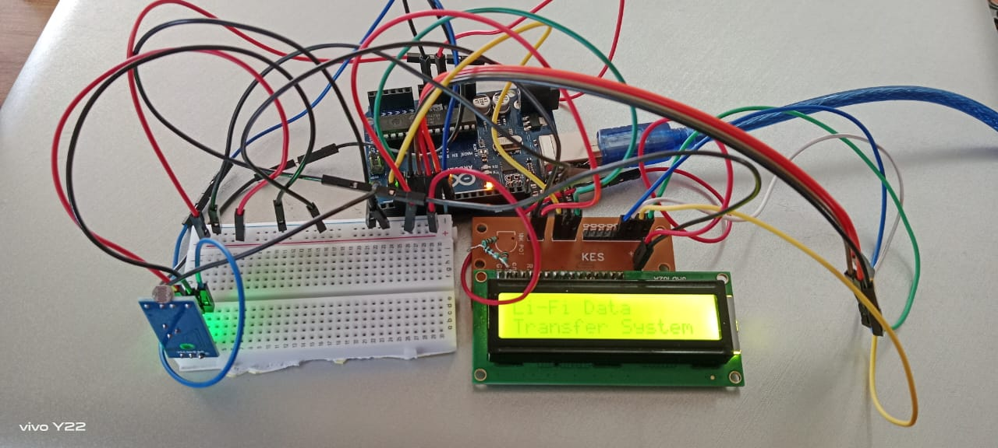

FIG 3.3 PRACTICAL IMPLEMENTATION OF RECEIVER

**3.3 SYSTEM MODEL:**

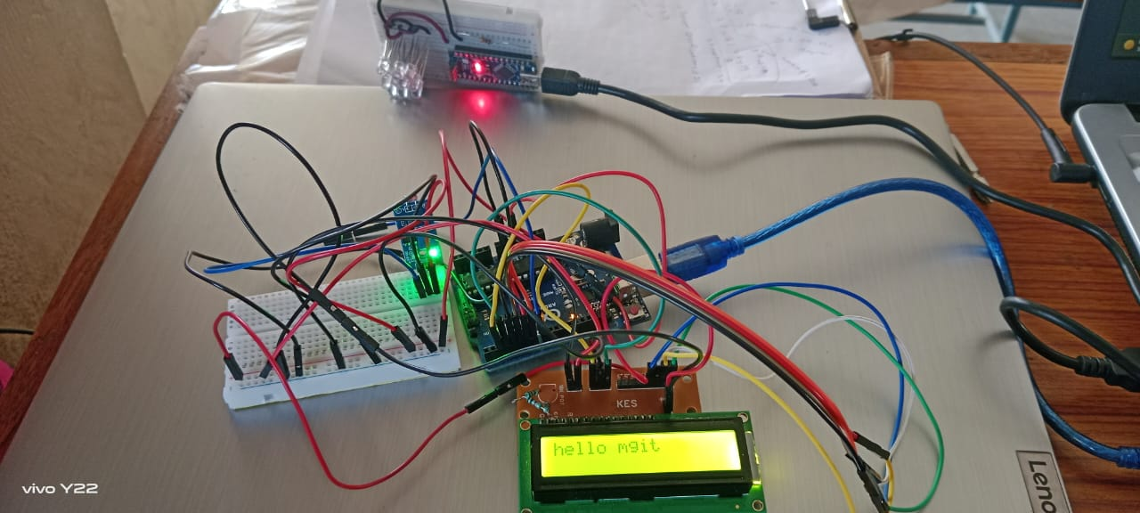

FIG 3.4 OVERALL SYSTEM

The figure above shows both the transmitter and receiver circuit being communicated using a light source that is a led. Numeric data and text are possible through this circuit using visible light communication. The lcd displays the output of the numeric matrix keypad. When a microphone is used to transmit the audio then speaker gives the output.

**CHAPTER 4**

**PROGRAM CODING**

**4.1 TRANSMITTER CODING:**

int led_pin=13;

//int data[27]={125, 250, 500, 625, 875, 1000, 1250, 1500, 1625, 1875, 2000, 2250, 2500, 2625, 2875, 3125, 3250, 3500, 3625, 3875, 4125, 4250, 4500, 4625, 4875, 5125, 5250};

void setup() {

Serial.begin(9600);

pinMode(led_pin,OUTPUT);

}

char rx_byte = 0;

void loop()

{

if(Serial.available()>0){

rx_byte = Serial.read();

}

if(rx_byte=='a')

{

digitalWrite(led_pin,HIGH);

delay(125);

digitalWrite(led_pin,LOW);

delay(500);

}

if(rx_byte=='b')

{

digitalWrite(led_pin,HIGH);

delay(250);

digitalWrite(led_pin,LOW);

delay(500);

}

if(rx_byte=='c')

{

digitalWrite(led_pin,HIGH);

delay(500);

digitalWrite(led_pin,LOW);

delay(500);

}

if(rx_byte=='d')

{

digitalWrite(led_pin,HIGH);

delay(625);

digitalWrite(led_pin,LOW);

delay(500);

}

if(rx_byte=='e')

{

digitalWrite(led_pin,HIGH);

delay(875);

digitalWrite(led_pin,LOW);

delay(500);

}

if(rx_byte=='f')

{

digitalWrite(led_pin,HIGH);

delay(1000);

digitalWrite(led_pin,LOW);

delay(500);

}

if(rx_byte=='g')

{

digitalWrite(led_pin,HIGH);

delay(1250);

digitalWrite(led_pin,LOW);

delay(500);

}

if(rx_byte=='h')

{

digitalWrite(led_pin,HIGH);

delay(1500);

digitalWrite(led_pin,LOW);

delay(500);

}

if(rx_byte=='i')

{

digitalWrite(led_pin,HIGH);

delay(1625);

digitalWrite(led_pin,LOW);

delay(500);

}

if(rx_byte=='j')

{

digitalWrite(led_pin,HIGH);

delay(1875);

digitalWrite(led_pin,LOW);

delay(500);

}

if(rx_byte=='k')

{

digitalWrite(led_pin,HIGH);

delay(2000);

digitalWrite(led_pin,LOW);

delay(500);

}

if(rx_byte=='l')

{

digitalWrite(led_pin,HIGH);

delay(2250);

digitalWrite(led_pin,LOW);

delay(500);

}

if(rx_byte=='m')

{

digitalWrite(led_pin,HIGH);

delay(2500);

digitalWrite(led_pin,LOW);

delay(500);

}

if(rx_byte=='n')

{

digitalWrite(led_pin,HIGH);

delay(2625);

digitalWrite(led_pin,LOW);

delay(500);

}

if(rx_byte=='o')

{

digitalWrite(led_pin,HIGH);

delay(2875);

digitalWrite(led_pin,LOW);

delay(500);

}

if(rx_byte=='p')

{

digitalWrite(led_pin,HIGH);

delay(3125);

digitalWrite(led_pin,LOW);

delay(500);

}

if(rx_byte=='q')

{

digitalWrite(led_pin,HIGH);

delay(3250);

digitalWrite(led_pin,LOW);

delay(500);

}

if(rx_byte=='r')

{

digitalWrite(led_pin,HIGH);

delay(3500);

digitalWrite(led_pin,LOW);

delay(500);

}

if(rx_byte=='s')

{

digitalWrite(led_pin,HIGH);

delay(3625);

digitalWrite(led_pin,LOW);

delay(500);

}

if(rx_byte=='t')

{

digitalWrite(led_pin,HIGH);

delay(3875);

digitalWrite(led_pin,LOW);

delay(500);

}

if(rx_byte=='u')

{

digitalWrite(led_pin,HIGH);

delay(4125);

digitalWrite(led_pin,LOW);

delay(500);

}

if(rx_byte=='v')

{

digitalWrite(led_pin,HIGH);

delay(4250);

digitalWrite(led_pin,LOW);

delay(500);

}

if(rx_byte=='w')

{

digitalWrite(led_pin,HIGH);

delay(4500);

digitalWrite(led_pin,LOW);

delay(500);

}

if(rx_byte=='x')

{

digitalWrite(led_pin,HIGH);

delay(4625);

digitalWrite(led_pin,LOW);

delay(500);

}

if(rx_byte=='y')

{

digitalWrite(led_pin,HIGH);

delay(4875);

digitalWrite(led_pin,LOW);

delay(500);

}

if(rx_byte=='z')

{

digitalWrite(led_pin,HIGH);

delay(5125);

digitalWrite(led_pin,LOW);

delay(500);

}

if(rx_byte==' ')

{

digitalWrite(led_pin,HIGH);

delay(5250);

digitalWrite(led_pin,LOW);

delay(500);

}

/*

for(int i=0; i<27; i++)

{

digitalWrite(led_pin,HIGH);

delay(data[i]);

digitalWrite(led_pin,LOW);

delay(500);

}

*/

}

**4.2 RECEIVER CODING:**

#include<LiquidCrystal.h>

LiquidCrystal lcd (2, 3, 4, 5, 6, 7);

#define ldr 8

int val;

int val2;

String duration;

int c=0;

void setup() {

// put your setup code here, to run once:

Serial.begin(9600);

pinMode(ldr, INPUT_PULLUP);

lcd.begin(16,2);

lcd.clear();

lcd.print("Mini Project");

lcd.setCursor(0,1);

lcd.print("Mentor: Balraju");

delay(3000);

lcd.clear();

lcd.print("Li-Fi Data");

lcd.setCursor(0,1);

lcd.print("Transfer System");

delay(3000);

lcd.clear();

lcd.print("Send any message");

lcd.setCursor(0,1);

lcd.print("From Transmitter");

delay(3000);

lcd.setCursor(0,0);

lcd.clear();

}

void loop() {

// put your main code here, to run repeatedly:

int val = digitalRead(ldr);

while(val == 0)

{

int val2 = digitalRead(ldr);

duration += val2;

if(duration == "01")

{

if(c==16){

lcd.scrollDisplayLeft();

c=15;

}

Serial.println("Received message: a");

c=c+1;

lcd.print("a");

}

if(duration == "001")

{

if(c==16){

lcd.scrollDisplayLeft();

c=15;

}

Serial.println("Received message: b");

c=c+1;

lcd.print("b");

}

if(duration == "0001")

{

if(c==16){

lcd.scrollDisplayLeft();

c=15;

}

Serial.println("Received message: c");

c=c+1;

lcd.print("c");

}

if(duration == "00001")

{

if(c==16){

lcd.scrollDisplayLeft();

c=15;

}

Serial.println("Received message: d");

c=c+1;

lcd.print("d");

}

if(duration == "000001")

{

if(c==16){

lcd.scrollDisplayLeft();

c=15;

}

Serial.println("Received message: e");

c=c+1;

lcd.print("e");

}

if(duration == "0000001")

{

if(c==16){

lcd.scrollDisplayLeft();

c=15;

}

Serial.println("Received message: f");

c=c+1;

lcd.print("f");

}

if(duration == "00000001")

{

if(c==16){

lcd.scrollDisplayLeft();

c=15;

}

Serial.println("Received message: g");

c=c+1;

lcd.print("g");

}

if(duration == "000000001")

{

if(c==16){

lcd.scrollDisplayLeft();

c=15;

}

Serial.println("Received message: h");

c=c+1;

lcd.print("h");

}

if(duration == "0000000001")

{

if(c==16){

lcd.scrollDisplayLeft();

c=15;

}

Serial.println("Received message: i");

c=c+1;

lcd.print("i");

}

if(duration == "00000000001")

{

if(c==16){

lcd.scrollDisplayLeft();

c=15;

}

Serial.println("Received message: j");

c=c+1;

lcd.print("j");

}

if(duration == "000000000001")

{

if(c==16){

lcd.scrollDisplayLeft();

c=15;

}

Serial.println("Received message: k");

c=c+1;

lcd.print("k");

}

if(duration == "0000000000001")

{

if(c==16){

lcd.scrollDisplayLeft();

c=15;

}

Serial.println("Received message: l");

c=c+1;

lcd.print("l");

}

if(duration == "00000000000001")

{

if(c==16){

lcd.scrollDisplayLeft();

c=15;

}

Serial.println("Received message: m");

c=c+1;

lcd.print("m");

}

if(duration == "000000000000001")

{

if(c==16){

lcd.scrollDisplayLeft();

c=15;

}

Serial.println("Received message: n");

c=c+1;

lcd.print("n");

}

if(duration == "0000000000000001")

{

if(c==16){

lcd.scrollDisplayLeft();

c=15;

}

Serial.println("Received message: o");

c=c+1;

lcd.print("o");

}

if(duration == "00000000000000001")

{

if(c==16){

lcd.scrollDisplayLeft();

c=15;

}

Serial.println("Received message: p");

c=c+1;

lcd.print("p");

}

if(duration == "000000000000000001")

{

if(c==16){

lcd.scrollDisplayLeft();

c=15;

}

Serial.println("Received message: q");

c=c+1;

lcd.print("q");

}

if(duration == "0000000000000000001")

{

if(c==16){

lcd.scrollDisplayLeft();

c=15;

}

Serial.println("Received message: r");

c=c+1;

lcd.print("r");

}

if(duration == "00000000000000000001")

{

if(c==16){

lcd.scrollDisplayLeft();

c=15;

}

Serial.println("Received message: s");

c=c+1;

lcd.print("s");

}

if(duration == "000000000000000000001")

{

if(c==16){

lcd.scrollDisplayLeft();

c=15;

}

Serial.println("Received message: t");

c=c+1;

lcd.print("t");

}

if(duration == "0000000000000000000001")

{

if(c==16){

lcd.scrollDisplayLeft();

c=15;

}

Serial.println("Received message: u");

c=c+1;

lcd.print("u");

}

if(duration == "000000000000000000000001")

{

if(c==16){

lcd.scrollDisplayLeft();

c=15;

}

Serial.println("Received message: v");

c=c+1;

lcd.print("v");

}

if(duration == "000000000000000000000001")

{

if(c==16){

lcd.scrollDisplayLeft();

c=15;

}

Serial.println("Received message: w");

c=c+1;

lcd.print("w");

}

if(duration == "0000000000000000000000001")

{

if(c==16){

lcd.scrollDisplayLeft();

c=15;

}

Serial.println("Received message: x");

c=c+1;

lcd.print("x");

}

if(duration == "00000000000000000000000001")

{

if(c==16){

lcd.scrollDisplayLeft();

c=15;

}

Serial.println("Received message: y");

c=c+1;

lcd.print("y");

}

if(duration == "000000000000000000000000001")

{

if(c==16){

lcd.scrollDisplayLeft();

c=15;

}

Serial.println("Received message: z");

c=c+1;

lcd.print("z");

}

if(duration == "0000000000000000000000000001")

{

if(c==16){

lcd.clear();

c=0;

}

Serial.println("Received message: _");

c=c+1;

lcd.print(" ");

}

if(val2 == 1)

{

duration = "";

break;

}

delay(200);

}

}

**CHAPTER 5**

**CODES FOR DATA TRANSMISSION**

1. **TRANSMITTER CHARACTER CODES:**

|  |  |
| --- | --- |
| CHARACTER | CHARACTER CODE |
| a | 125 |
| b | 250 |
| c | 500 |
| d | 625 |
| e | 875 |
| f | 1000 |
| g | 1250 |
| h | 1500 |
| i | 1625 |
| j | 1875 |
| k | 2000 |
| l | 2250 |
| m | 2500 |
| n | 2625 |
| o | 2875 |
| p | 3125 |
| q | 3250 |
| r | 3500 |
| s | 3625 |
| t | 3875 |
| u | 4125 |
| v | 4250 |
| w | 4500 |
| x | 4625 |
| y | 4875 |
| z | 5125 |
| ‘ ’-space | 5250 |

Table 5.1 Transmitter Character Codes

1. **RECIEVER CHARACTER CODES:**

|  |  |
| --- | --- |
| CHARACTER | CHARACTER CODE |
| a | 01 |
| b | 001 |
| c | 0001 |
| d | 00001 |
| e | 000001 |
| f | 0000001 |
| g | 00000001 |
| h | 000000001 |
| i | 0000000001 |
| j | 00000000001 |
| k | 000000000001 |
| l | 0000000000001 |
| m | 00000000000001 |
| n | 000000000000001 |
| o | 0000000000000001 |
| p | 00000000000000001 |
| q | 000000000000000001 |
| r | 0000000000000000001 |
| s | 00000000000000000001 |
| t | 000000000000000000001 |
| u | 0000000000000000000001 |
| v | 00000000000000000000001 |
| w | 000000000000000000000001 |
| x | 0000000000000000000000001 |
| y | 00000000000000000000000001 |
| z | 000000000000000000000000001 |
| ‘ ’-space | 0000000000000000000000000001 |

Table 5.2 Receiver Character Codes

**CHAPTER 6**

**OBSERVATIONS**

|  |  |
| --- | --- |
| PARAMETERS | OBSERVATION |
| Height at which the torch can be kept for Li Fi communication to take place | Minimum height: 7 cm  Maximum height: 75 cm |
| Light allowance | Data transmission occurs at every LED light that has a microcontroller operation attached with it. |
| Temperature range | 0 - 70 Degree Celsius |

Table 6.1 OBSERVATION TABLE

**CHAPTER 7**

**DISCUSSION**

Li-Fi communication that we have worked with uses light frequencies rather than the usual radio waves. Embedded with a microchip that produces a signal, the LED yields rates much faster than the usual internet connection speed we have.

The LED’s used in Transmitter are able to transmit the data without any error. The increase or decrease of intensity will not affect the communication between the transmitter and receiver if the light is visible. If we increase the distance between the transmitter and receiver up to one meter, the receiver is able to detect the light and display the data that is transmitted.

When the obstacle is present between the transmitter and receiver, the receiver is unable to detect the light and it displays nothing on LCD. A paper, an object, cloth, hand, person as obstacle is experimented and output is not displayed.

The receiver is able to detect the light transmitted from transmitter even when the data is transmitted in the room light. It is also observed that, the data is transmitted even under the shadow of the tree.

It is worth mentioning that each experiment explained above is conducted for several time to figure out the effect of increasing the distance between transmitter part and receiver part on system performance. The result show that the effect of increasing distance up to 30 cm does not effect on the data transmission rate. While the intensity of flashlight begins to fade at distance higher than 30 cm, so that, the light sensor at the receiver part can’t able to detect the sent data. Besides that, if the distance is increased, an interference is occurred between light of smartphone’s flash and light of other sources in the room, which leads to the data transmission with noise.

**CHAPTER 8**

**RESULTS**

This experiment provided an insight into the upcoming technology i.e., data communication using LED light. The communication of alphanumeric data in this experiment was done using a simple Arduino Uno and Nano and it enabled the data to be transmitted and received effectively. We also concluded that any LED light that has the microcontroller operation embedded with it can be used for the data transmission and reception. Moreover, the increase or decrease of intensity will not affect the communication between the transmitter and receiver if the light is visible. However, when there is an obstacle in between the light and the photodiode, the data transmission does not take place.

So, an unobstructed light is required for continuous communication. This technology cannot be used to transmit over solid materials or opaque structures but this can be advantageous in a way that it is more secure and safer in comparison to WIFI as data theft will not be an issue here.

The main purpose of our proposed project is to deploy a communication system based on Li-Fi technology that is capable of transferring data from transmitter part to receiver part. It has been successfully enabled sending text data via using flash of built-in smartphone camera as a media of communication, and receiving it correctly at the receiver part. However, this proposed system achieves 100bps data bit rate even if used the phototransistor, which is faster than LDR and BH1750.

Therefore, there are some enhancements can be taken into account in further research to improve the data bit rate above 100 bps, these are given as follows:

• It will examine replacing OOK modulation scheme PWM.

• It can be experienced using simple circuit in the transmitter part, which consists of Arduino UNO and array of high-power LEDs instead of using flashlight of smartphone.

• In order to increase the data bit rate, it can be suggested connecting fast photodiode sensor, its response time in nanoseconds, to Arduino UNO at receiver part and check the data bit rate under this situation.

**CHAPTER 9**

**CONCLUSION AND FUTURE SCOPE**

**9.1 CONCLUSION:**

The project deals with designing a simple and low-cost data communication system using LED, DTMF transmitter and receiver, LCD, ATMEGA-8 microcontroller unit that transmits numeric data and also helps in audio communication. The project module is designed at the preliminary stage that reads numeric data and special characters *, # and makes audio communication possible but it can be enhanced further to read alpha-numeric data as well as to enable video communication using camera or some digital device.

The possibilities are numerous and can be explored further. If this technology can be put into practical use, every bulb can be used something like a Wi-Fi hotspot to transmit wireless data and we will proceed towards the cleaner, greener, safer and brighter future. The concept of Li-Fi is currently attracting a great deal of interest, not least because it may offer a genuine and very efficient alternative to radio-based wireless. As a growing number of people and their many devices access wireless internet, the airwaves are becoming increasingly clogged, making it more and more difficult to get a reliable, high-speed signal. This may solve issues such as the shortage of radio-frequency bandwidth and also allow internet where traditional radio-based wireless isn’t allowed such as aircraft or hospitals. One of the shortcomings however is that it only works in direct line of sight.

**9.2 FUTURE SCOPE:**

Li-Fi is expected to be ten times cheaper than Wi-Fi. Li-Fi has the advantage of being able to be used in electromagnetic sensitive areas such as in aircraft and nuclear power plants without causing interference. The light waves cannot penetrate walls which makes a much shorter range, though more secure from hacking, relative to Wi-Fi. While the US Federal Communications Commission has warned of a potential spectrum crisis because Wi-Fi is close to full capacity, Li-Fi has almost no limitations on capacity. The visible light spectrum is 10,000 times larger than the entire radiofrequency spectrum. Researchers have reached data rates of 3.5 Gbps and have set a goal of reaching 6 Gbps. The Li-Fi market is projected to be worth over $6 billion per year by 2018.  Low reliability and high installation costs are the potential drawbacks.

**9.3 APPLICATION AREA OF LI-FI TECHNOLOGY:**

* Airways: -

Whenever we travel through airways we face the problem in communication media, because the whole airways communication is performed on the basis of radio waves. To overcome this drawback on radio ways, Li-Fi is introduced.



Fig 8.1 Airways

* Green information technology: -

Green information technology means that unlike radio waves and other communication waves effects on the birds, human body etc. Li-Fi never gives such side effects on any living thing.

* In hospitals where mobile phones are not allowed and certain devices may disrupt due to the radio waves. Here Li-Fi technology will be the best used up technology



Fig 8.2 Li-Fi in Hospitals

* Free From Frequency Bandwidth Problem: -

Li-fi is a communication media in the form of light, so no matter about the frequency bandwidth problem. It does not require the any bandwidth spectrum i.e.; we don’t need to pay any amount for communication and license.

* Increase Communication Safety: -

Due to visual light communication, the node or any terminal attach to our network is visible to the host of network.

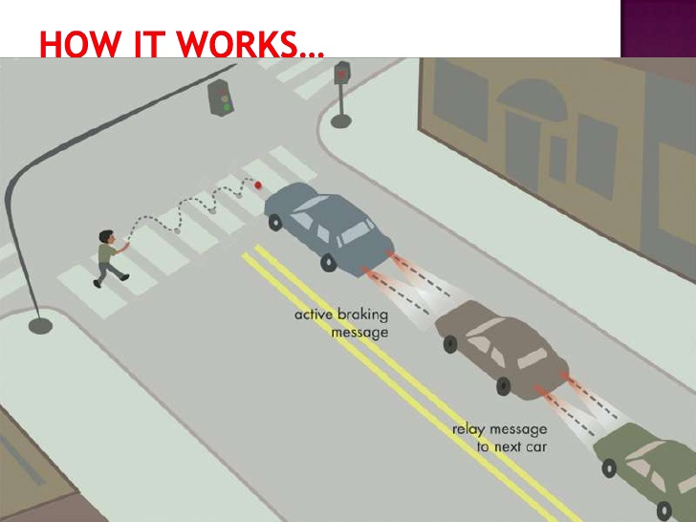

Fig 8.3 Traffic Communication

* Multi User Communication: -

Li-Fi supports the broadcasting of network, it helps to share multiple things at a single instance called broadcasting.

* Street lights can be the free access point as they are deployed everywhere



Fig 8.4 Street Light Communication

* Lightings Points Used as Hotspot: -

Any lightings device is performed as a hotspot it means that the light device like car lights, ceiling lights, street lamps etc. area able to spread internet connectivity using visual light communication which helps us to connect low-cost architecture for hotspot. Hotspot is a limited region in which some amount of device can access the internet connectivity.

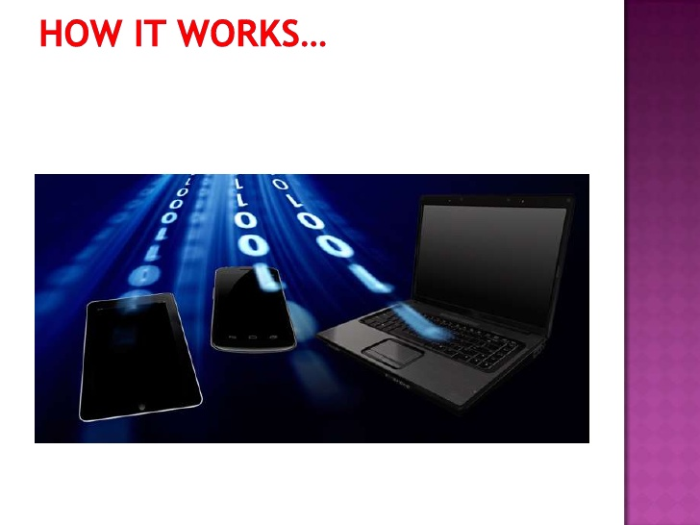

Fig 8.5 Li-Fi Hotspots

* Smarter Power Plants: -

Wi-Fi and many other radiation types are bad for sensitive areas. Like those surrounding power plants. But power plants need fast, inter-connected data systems to monitor things like demand, grid integrity and (in nuclear plants) core temperature. The savings from proper monitoring at a single power plant can add up to hundreds of thousands of dollars. Li-Fi could offer safe, abundant connectivity for all areas of these sensitive locations. Not only would this save money related to currently implemented solutions, but the draw on a power plant’s own reserves could be lessened if they haven’t yet converted to LED lighting.

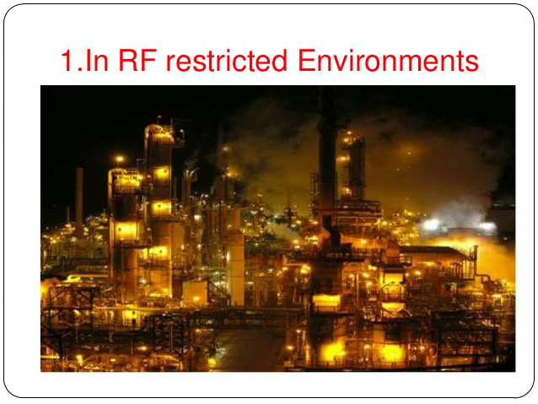

Fig 8.6 Smart Power Plants

* Undersea Awesomeness: -

Underwater ROVs, those favourite toys of treasure seekers and James Cameron, operate from large cables that supply their power and allow them to receive signals from their pilots above. ROVs work great, except when the tether isn’t long enough to explore an area, or when it gets stuck on something. If their wires were cut and replaced with light — say from a submerged, high-powered lamp — then they would be much freer to explore. They could also use their headlamps to communicate with each other, processing data autonomously and referring findings periodically back to the surface, all the while obtaining their next batch of orders.

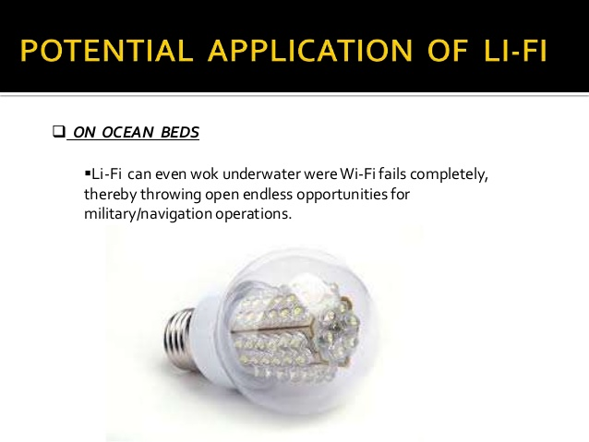

Fig 8.7 Undersea Communication

**REFERENCES**

1. B. Ekta and R. Kaur, “Light Fidelity (LI-FI) – A Comprehensive Study”, International Journal of Computer Science and Mobile Computing, Vol.3, Issue 4, pg. 475- 481, ISSN 2320 – 088X, April- 2014.

2. Serafimovski. N, “What is Li-Fi?”, in the pureLiFi project for Wireless Personal Area Networks (WPANs), Edinburgh UK, January 2015.

3. H. Haas, “Wireless Data from Every Light Bulb.”,Internet: http://bit.ly/tedvlc, Aug. 2011 [Dec 30, 2017]

4. D. Tsonev, S. Videv and H. Haas, “Light Fidelity (Li- Fi): towards all-optical networking”, Proc. SPIE 9007, Broadband Access Communication Technologies VIII

conference, December 18, 2013.

5. S. Dimitrov and H. Haas, “Principles of LED Light Communications: Towards Networked Li-Fi”, Cambridge, United Kingdom: Cambridge University Press, 2015.

6. M. Watts, “Meet Li-Fi, the LED-based alternative to household Wi-Fi,” Wired Magazine.

7. T. Lain, “Forget Wi-Fi, boffins get 150Mbps Li-Fi connection from a lightbulb The Register”, Internet: http://www.theregister.co.uk/2013/10/18/forget_wifi_ chinese_boffins_get_150mbps_lificonnection_from_a_lightbulb, 2013. [Dec 30, 2017].

8. Badamasi, Y.A., “The Working Principle of an Arduino.” 11th International Conference on Electronics, Computer and Computation (ICECCO), Abuja, 29 September-1

October 2014.

9. A. Malvino, D. J. Bates, “Electronic Principles”, 7th Edition (2007), ISBN 0-7-063424-6, New Delhi,India.

10. S. Dong et al., "A Voice Transmission System Based on Visible Light Communication", Proc. of the IEEE 5 th Global Conf. on Consumer Electronics , pp. 1-2.

11. Data Transmission using Visible Light Communication - IJEAT

12. Text, Voice and Image Transmission Using Visible Light Communication – IRJET

13. Transmission and Reception of Images via Visible Light – Instituto Politecnico Nacional, CIC, Mexico

14. [www.alldatasheet.com](http://www.alldatasheet.com)

15. [www.datasheetarchive.com](http://www.datasheetarchive.com)

16. [www.electrotechonline.com](http://www.electrotechonline.com)

17. [www.electronicsforu.com](http://www.electronicsforu.com)

18. Linear integrated circuits by D.ROY CHOUDHURY